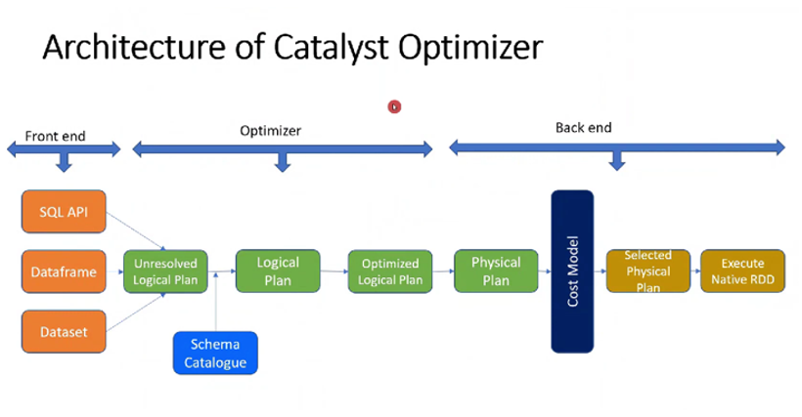
Let's understand this diagram of Catalyst Optimizer architecture in layman’s terms, using a simple real-world analogy: 🍕 ordering and preparing pizza in a smart kitchen.

🟠 Front End – You place your order
This is where you write your query (SQL, DataFrame, or Dataset).
- SQL API / DataFrame / Dataset = Your way of telling the kitchen:
“I want a pizza with extra cheese and no onions.”

🟡 Unresolved Logical Plan – The kitchen heard your order, but needs to double-check details
Spark understands the query, but hasn’t yet verified everything.
The kitchen got your order, but they need to check:
- Do we have “cheese”?
- What does “extra” mean?
- Is “onions” an allowed topping?
It refers to the Schema Catalogue (like a recipe book or inventory) to validate your request.

🟢 Logical Plan – Now the kitchen knows what you're asking for
Everything is valid. Spark builds a clear step-by-step plan, but it's not optimized yet.
The kitchen has now clearly written down:
- Get dough
- Add sauce
- Add cheese (extra)
- Skip onions
- Bake

🟢 Optimized Logical Plan – The smart manager improves your order process
Spark applies optimization rules: simplify steps, remove duplicates, rearrange tasks.
Manager says:
- We can skip fetching toppings we don’t need
- Bake while prepping the next pizza (parallel work)
- Use pre-shredded cheese to save time

🟢 Physical Plan – Decide how to actually execute the task
Now Spark decides how to run this optimized plan in the real kitchen (cluster).
Manager plans:
- Who (which cook/node) will do what
- What tool to use (pan vs oven)
- How to share ingredients (broadcast vs shuffle)

🔵 Cost Model – Pick the most efficient method
Spark checks the cost of different cooking options and chooses the fastest and cheapest one.
Should we:
- Use oven A (takes 5 mins but expensive)?
- Use oven B (slower but cheaper)?
It picks the best based on cost vs performance.

🟡 Selected Physical Plan – Final kitchen instruction sheet
“Use Oven B with 2 cooks and start in parallel with drinks.”

🟢 Execute Native RDD – Kitchen starts cooking
Spark now executes the plan and processes data using low-level RDDs.
Pizza is finally being made and delivered 🍕

🔁 Recap Table:
Stage | Real-world Analogy | What Spark Does
SQL/DataFrame/Dataset | Customer order | You submit a query
Unresolved Logical Plan | Order is heard, but not yet verified | Syntax understood, but columns/tables unchecked
Logical Plan | Clear plan made | Valid query steps formed
Optimized Logical Plan | Smart manager improves steps | Optimization rules applied
Physical Plan | Decide exact cooking steps | Physical execution plan created
Cost Model | Pick fastest, cheapest cooking way | Best execution method chosen
Selected Physical Plan | Final kitchen instruction | One plan selected
Execute Native RDD | Cook & deliver food | Data processing starts

Would you like to see this whole journey on a real query example like a SELECT from a table?

